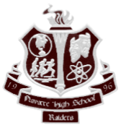
Navarre High School
Positive Behavior Recognition (PBR)
Recognition for "OWNing IT!"

Student Name: _________________________________________
Date: _________ Time: __________

Exemplified:
- One Family
- Working on the Work
- Navigating with Purpose
- Innovating Solutions
- Thinking with Integrity
Location:
- Media Center
- Cafeteria
- Bus Ramp
- Parking Lot
- Gym

- Classroom
- Office
- Campus Grounds
- Hallway
- Other ____________________

When students contribute positively to the culture of our campus, the entire NHS family benefits. Please know that your student has made a difference at NHS today!
Reason for Recognition:

Recognized By: ______________________________________________
Students receiving PBRs will be entered monthly into drawings for various prizes.

